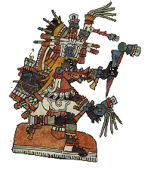 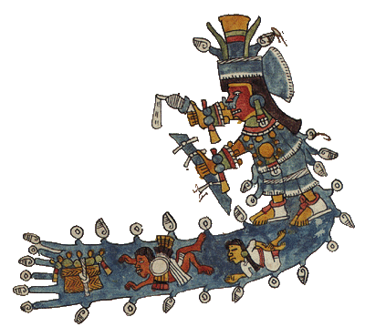

“Honoring R. Joe Campbell”

Association of Nahuatl Scholars Conference

SCHEDULE

April 25-27

Hosted by

Department of Spanish and Portuguese

Center for Latin American and Caribbean Studies

Global Indigenous Studies Network

Indiana University

Bloomington, IN

Biddle Memorial Union

Indiana University

Bloomington, IN

Thursday, April 25

8:30 - 9:20 Registration

Pre-Hispanic:

9:20 - 9:30 Welcome from Dr. Serafin Coronel-Molina, Director of CLACS

9:30 - 10:00 John F. Schwaller. Chicomecoatl: A deity rooted in the calendar and nature.

10:00 -10:30 Agnieszka Brylak. In Search of pre-Hispanic Nahua Gods of Laughter and Buffooneries.

10:30 - 10:45 BREAK

10:45 - 11:15 James Maffie. The Mexica Huey Tzompantli: A Metaphysical Understanding.

11:15 - 11:45 Amos Megged. The Birth and Death of Ixtlilxochitl in the Codex Xolotl.

11:45 - 12:15 Ben Leeming. “(Re)presenting the divine: The uses of teixiptla in Nahuatl-Christian texts and contexts.”

12:15 - 1:15 LUNCH BREAK

1:15 - 1:45 Keynote Address:

Joe Campbell and Mary Clayton. Two variable processes in Nahuatl phonology

Early Colonial:

1:45 - 2:15 Jongsoo Lee. Reinterpreting the Huehuetlatolli in Prehispanic Mexico: A New Perspective

2:15 - 2:45 Szymon Gruda. Courtly languages, obscure languages, and Satanic roots of linguistic diversity: Language ideologies in early colonial Mexico

2:45 - 3:00 BREAK

3:00 - 3:15 Special Session: Joe Campbell, Hard words.

4:00 - 4:30 Justyna Olko. Beyond stages: Nahuatl-Spanish contact and the mechanisms of sociolinguistic change.

4:30 - 5:00 Katarzyna Granicka. “The people have been in common possession of the land since time immemorial.” Indigenous communities of Tlaxcala facing the loss of the common lands in 1856.

5:15 Special Exhibit Lilly Library

Friday, April 26

8:30 - 9:00 Registration

9:00 - 9:30 Szymon Gruda, Gregory Haimovich & Justyna Olko. Nahuatl and other languages in Sierra Norte de Puebla: A critical overview of inter-ethnic relationships and patterns of multilingualism

Sahagun, the Florentine Codex, and the Sahagun era:

9:30 - 10:00 Robert Pugh, Frances M. Tyers, and Valery A. Berthoud F. An open, searchable, morphosyntactically annotated corpus of the Florentine Codex: A progress report on 'The Omens.'

10:00 - 10:30 Javier Eduardo Ramírez López. Who gives more: The works of Fray Bernardino de Sahagún for sale?

10:30 - 10:45 BREAK

10:45 - 11:15 Andrea Reed-Leal. Female Textile Knowledge in the Florentine Codex.

11:15 - 11:45 Estefany Sosa and Fran Tyers. Nahuatl Lexical Locative Distribution Patterns in the Florentine Codex.

11:45 - 12:15 Barbara Mundy. Paper matters: the material of the Sahagún corpus.

12:15 - 1:15 LUNCH BREAK

1;15 - 1:45 Andrew Laird. Latin and Nahuatl in Francisco Hernández

More Colonial:

1:45 - 2:15 Jose Estrada. Found in Translation: Don Bartolomé de Alva’s Nahuatl Interpretation of Spanish Baroque Theater.

2:15 - 2:30 BREAK

2:30 - 3:30 Document Session: Mark Christensen. “Christ’s Descent from the Cross in an Eighteenth-Century Sermon”

3:30 - 4:00 Katarzyna Szoblik and Katarzyna Granicka. "Why is San Francisco a woman?

Puzzling fragments of the Cihuacuicatl of the manuscript of *Cantares Mexicanos*."

4:00 - 5:00 Special Session: Gordon Whittaker, Nahuatl Glyph Workshop

Dinner - Crazy Horse

Saturday, April 27

9:00 - 9:30 Registration

Colonial and Contemporary Issues in Nahuatl:

9:30 - 10:00 Eduardo H. Gorobets Martins. In Moiollotzin, In Monacaiotzin: Revisiting Nahua Colonial Conceptions for the Human Body

10:00 - 10:30 Carlos Macias Prieto. “A Nahuatl Rewriting of Henrico Martínez’s *Reportorio de los tiempos* (1606): Domingo Chimalpahin’s Systematic Revision of Martínez’s Narrow Historical Narrative and His Critique of Spanish Men of Letters.”

10:30 - 10:45 BREAK

10:45 - 11:15 Heréndira Tellez. “Urbs beata Hierusalem ipoliuhca: nuevos testimonios en náhuatl sobre la Destrucción de Jerusalem”

11:15 - 11:45 Molly H. Bassett and Abelardo de la Cruz. “Indigenous and non-Indigenous Collaborations in Nahua(tl) Studies”

11:45 - 12:15 Citlalli Garcia. Curricular Analysis of Nahuatl Revitalization Via Macehualli-Centered Content and Practices.

12:15- 1:15 LUNCH BREAK

1:15 - 1:30 John Schwaller, Molina Life of St. Francis Project

1:30 - 2:00 Cecilia Solís-Barroso. A Generational Analysis of Variation and Change in the Noun Phrase Morphosyntax of Huasteca Nahuatl.

2:00 - 2:30 John Sullivan. The Nahua principle of syntactic balance in older and modern sources.

2:30 - 3:00 Nadia Cervantes Pérez, Humberto Iglesias Tepec, and Alanna S. Radlo-Dzur. “Translating Mesoamerica”: Learning about Indigenous Cultures through Princeton’s Nahuatl Documents from Colonial Mexico & Central America